**CAPSTONE PROJECT**

**Covid-19 Forecasting**

**SUBMITTED**

**BY**

**DHINESH S R**

**Table of Contents**

1. Problem Statement

2. Project Objective

3. Data Description

4. Data Pre-processing Steps and Inspiration

5 EDA

6. Choosing the Algorithm for the Project

7. Model Evaluation and Techniques

8. Conclusion

9. References

1. **Problem Statement**

Given data about COVID-19 patients, write code to visualize the impact and analyse the trend of rate of infection and recovery as well as make predictions about the number of cases expected a week in future based on the current trends.

1. **Project Objective**

* Use pandas to accumulate data from multiple data files.
* Use plotly (visualization library) to create interactive visualizations.
* Use Facebook prophet library to make time series models.
* Visualize the prediction by combining these technologies.

1. **Data Description**

CSV and Excel files containing data about the number of COVID-19 confirmed deaths and recovered patients both around the world and in India.

**Loading Dataset**

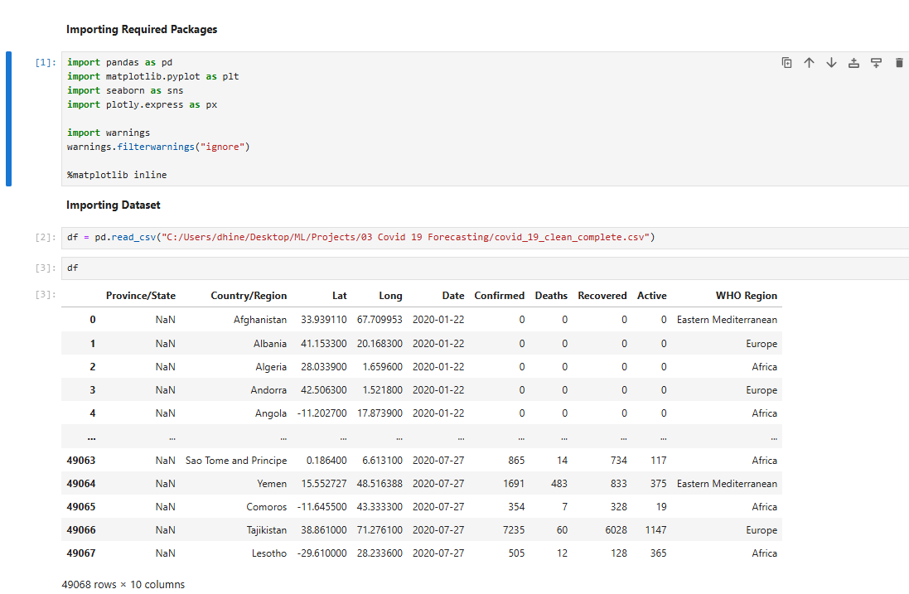

**Dataset Info**

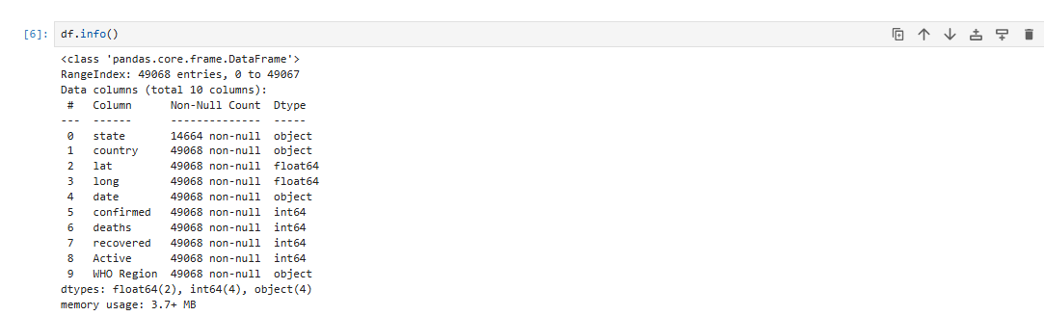

1. **Data Pre-processing Steps and Inspiration**

**Change Column Name as Easy to Access**

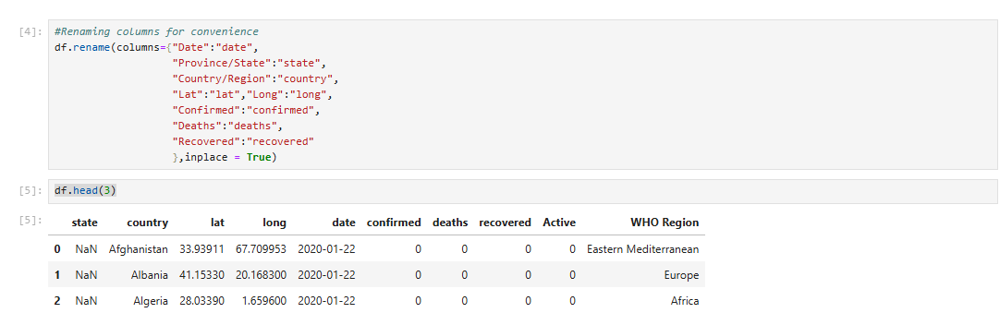

**Check Active Cases Are Correct**

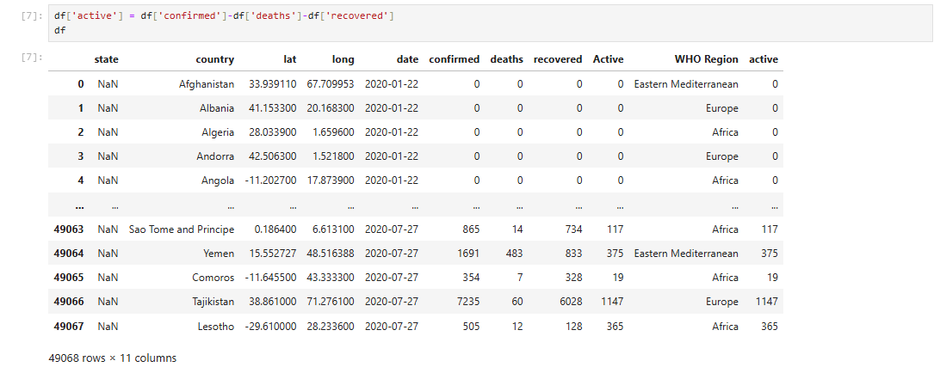

1. **EDA Results**

**EDA To Check Maximum Case**

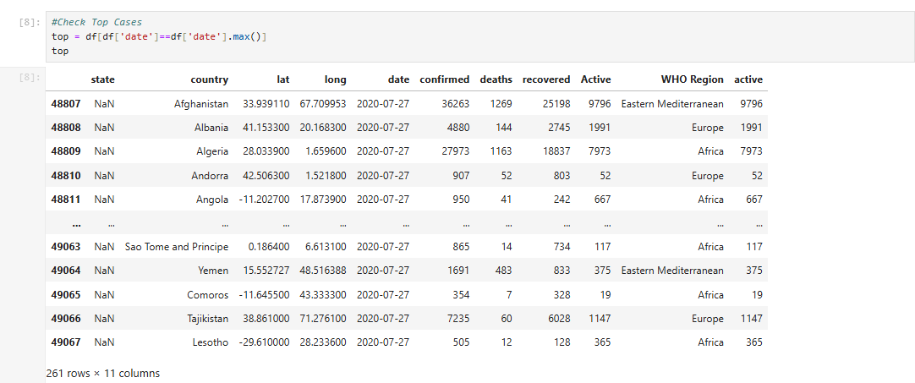

**Country wise Case List**

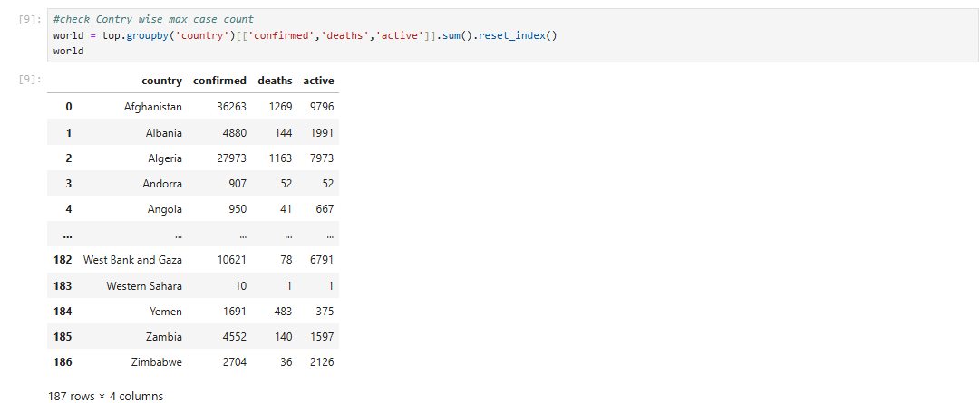

**Country Wise Case Using choropleth Plotly Visualization**

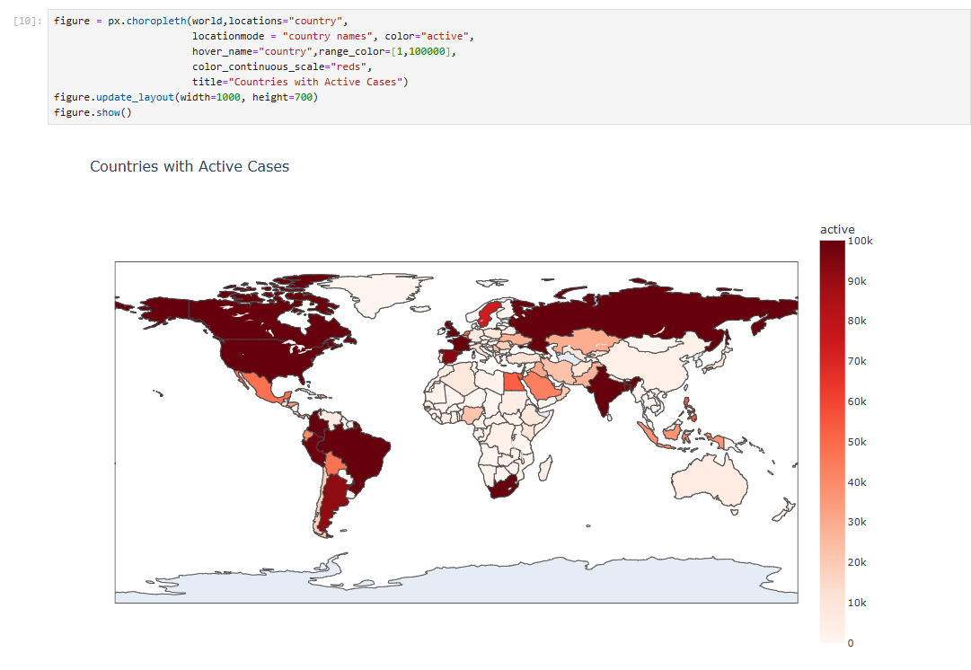

**Covid Trend on World Wise**

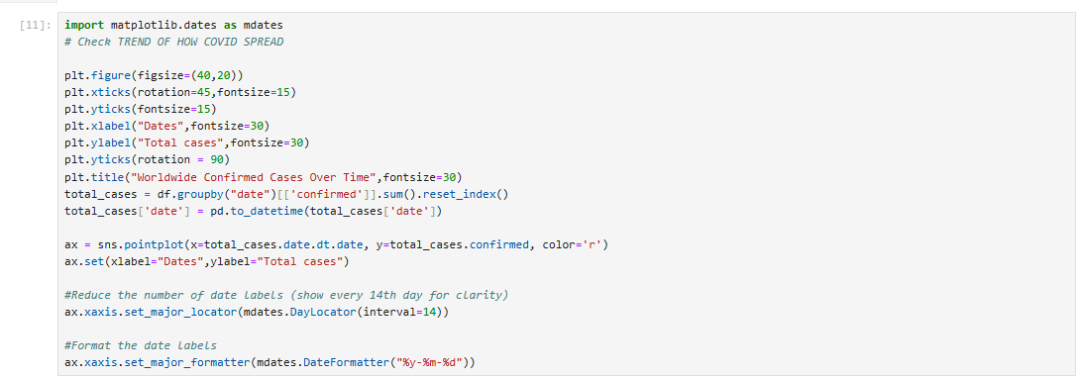

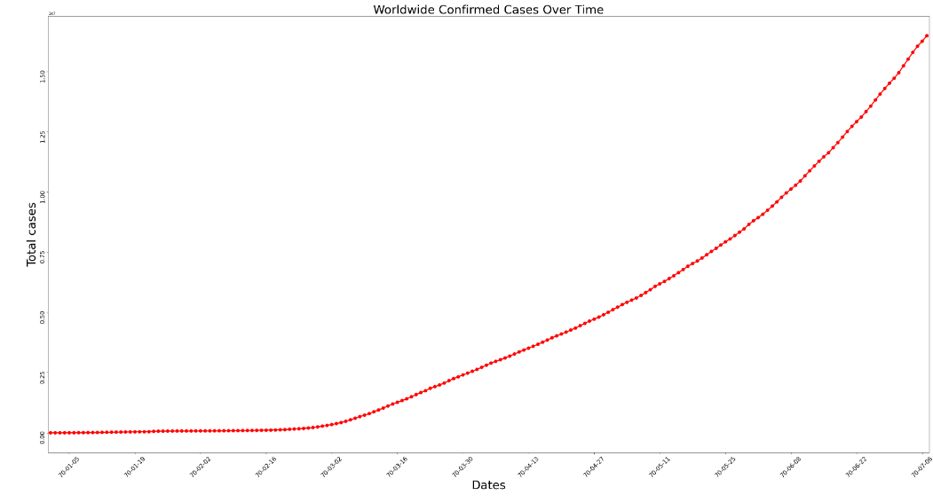

**Most Active Case in top 20 Country**

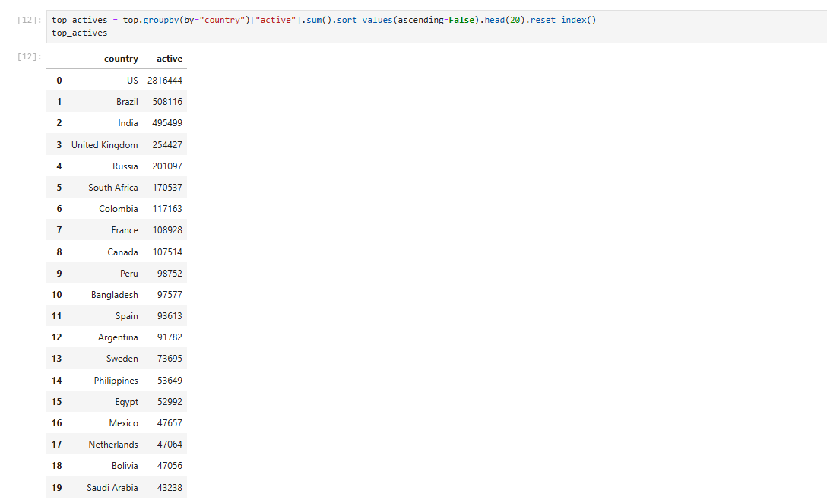

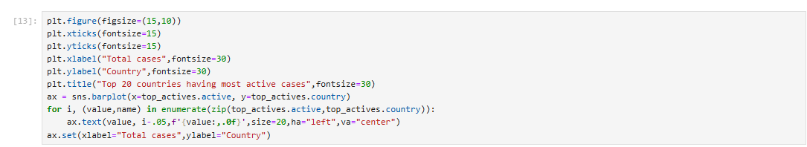

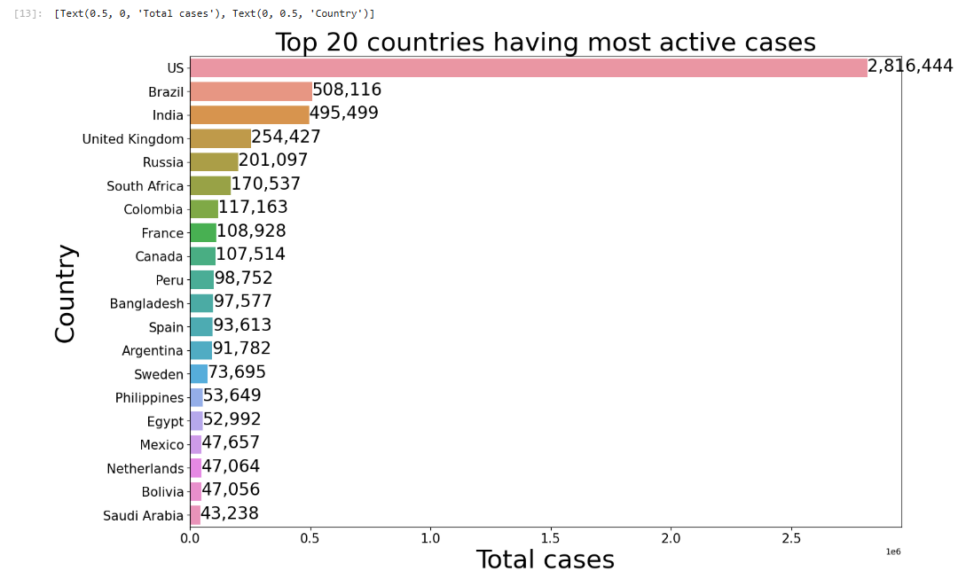

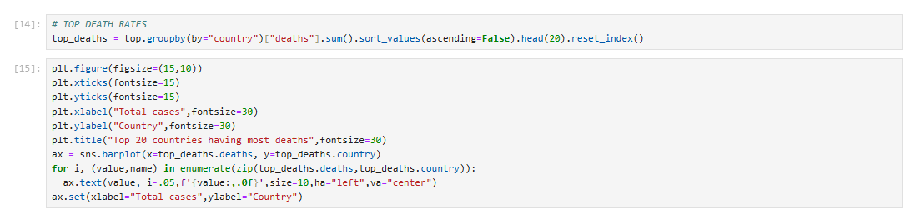

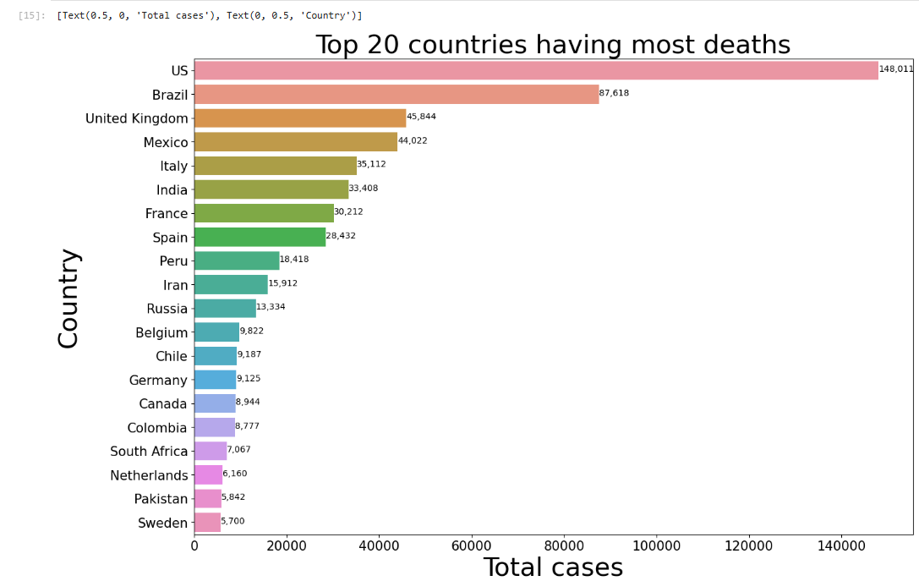

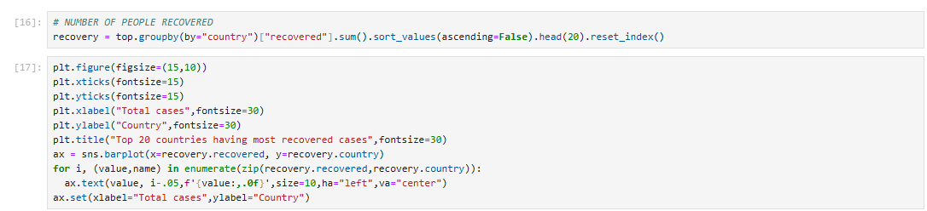

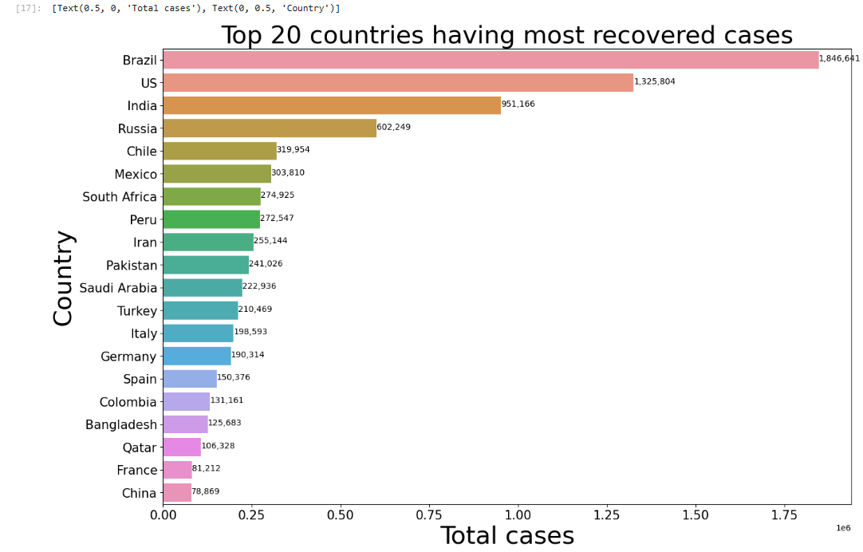

**Confirmed cases over time**

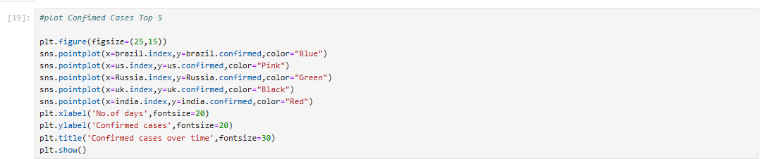

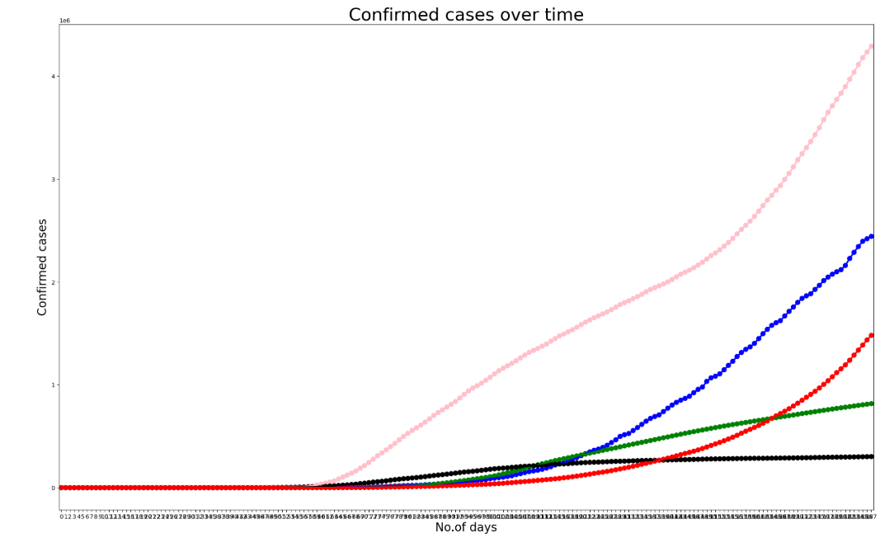

1. **Choosing the Algorithm for the Project**

Using Prophet Library for Forecasting

from prophet import Prophet

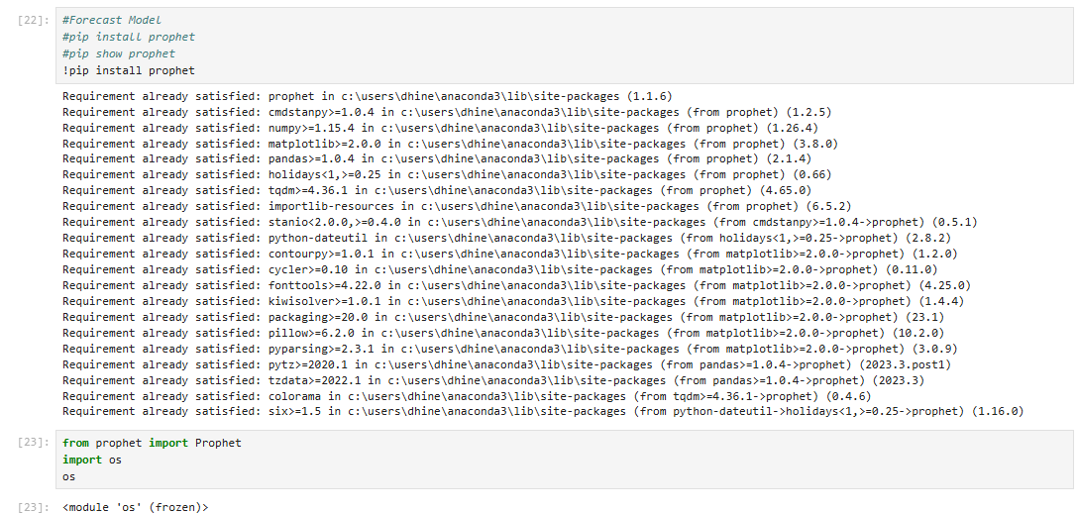

#change column name for prophet library require

# ds = datetime

#y target value

confirmed.columns = ['ds','y']

confirmed ['ds']=pd.to_datetime(confirmed['ds'])

**7 Model Evaluation and Techniques**

Plotting Forecasting Confirmed Cases

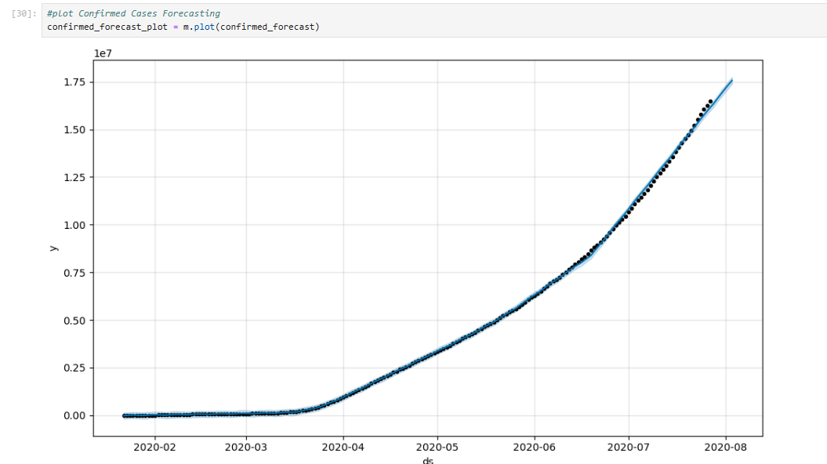

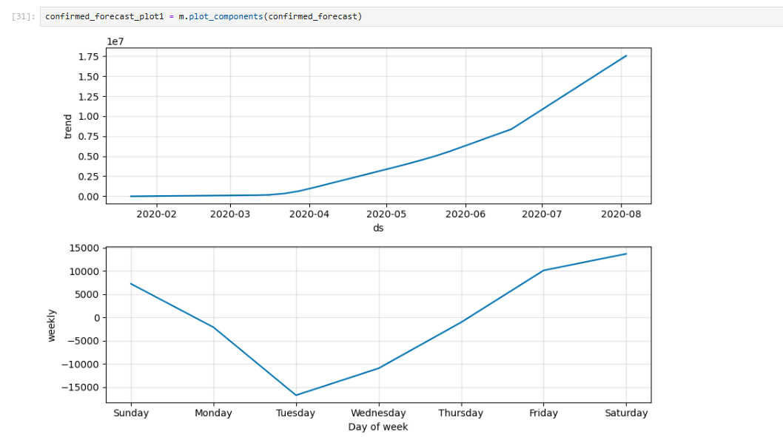

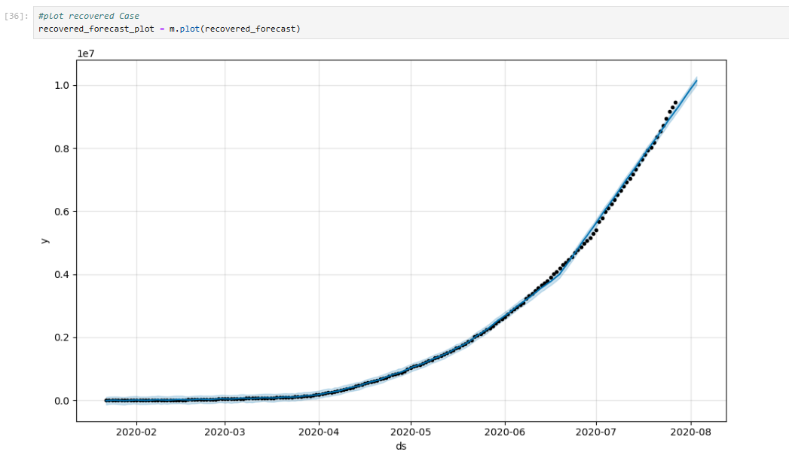

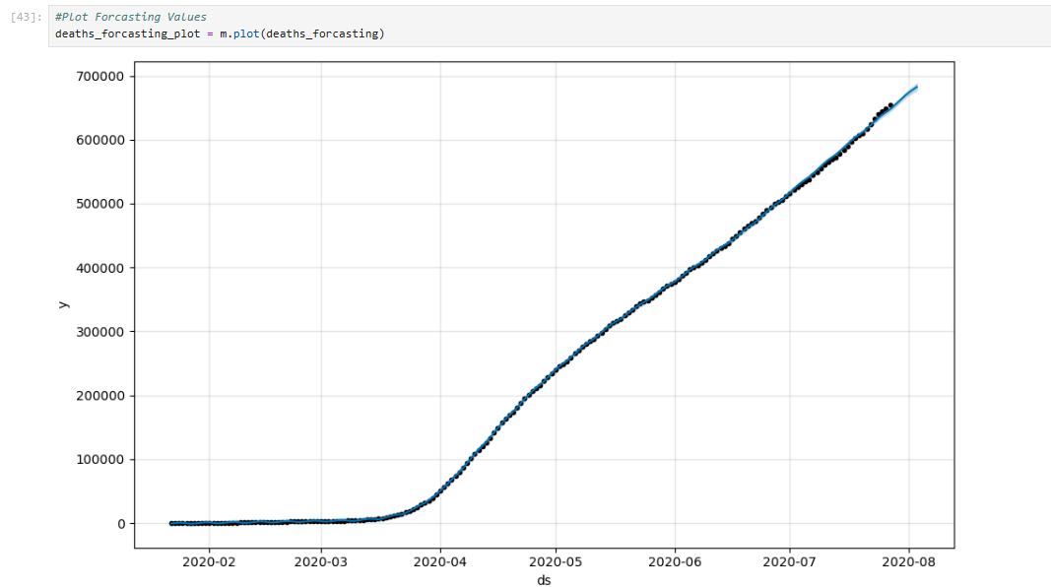

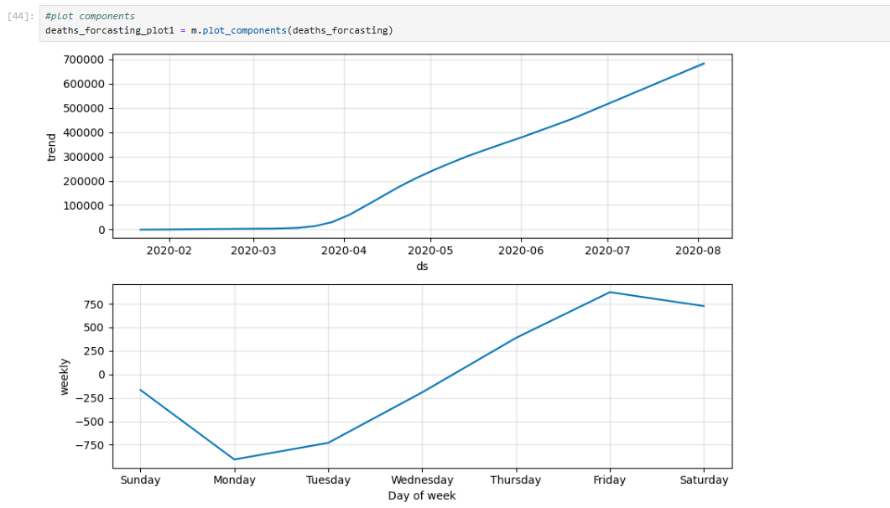

**8 Conclusion**

Prophet forecasting Model Gives better Results

**9. References**

* Intellipaat Session Live Class (For Forecasting)
* Chat GPT
* Kaggle